# **Movie Recommendation Engine**

Recommendation engines are an automated form of a “shop counter guy”. You ask him for the product. Not only he shows that product, but also the related ones which you could buy. The ability of these engines to recommend personalized content, based on past behavior is incredible. It brings customer delight and gives them a reason to keep returning to the website.

**Client**

Many online businesses rely on customer reviews and ratings. Explicit feedback is especially important in the entertainment and ecommerce industry where all customer engagements are impacted by these ratings. Netflix relies on such rating data to power its recommendation engine to provide the best movie and TV series recommendations that are personalized and most relevant to the user.

**Data Set:** The MovieLens DataSet

We will be using the MovieLens dataset for this purpose. It has been collected by the GroupLens Research Project at the University of Minnesota. MovieLens 100K dataset consists of:

* **100,000 ratings** (1-5) from 943 users on 1682 movies.
* Each user has rated **at least 20 movies.**
* Simple demographic info for the users (age, gender, occupation, zip)
* Genre information of movies

## Data Wrangling

First, we input data & do data wrangling. The primary data source is MovieLens dataset which includes 3 .dat file for movies, users and ratings. We loaded each dataset to different dataframe.

We see first five rows of each data frame:

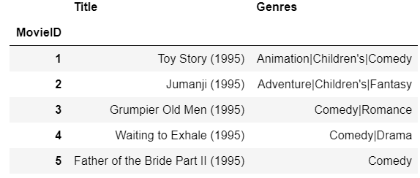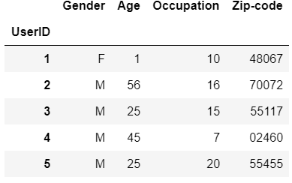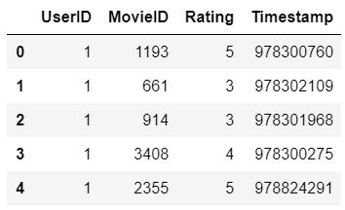

We conduct the following steps to clean up data and pick useful features.

1. Merge all 3 tables to one table and mapped each column which has code to real data and picked useful columns for further analysis

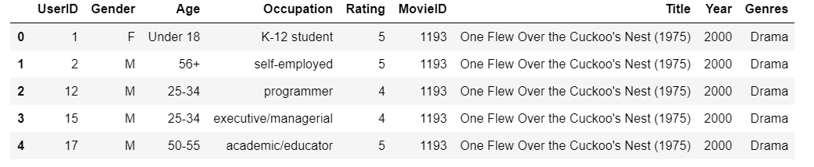

1. Search for missing values and filling them with appropriate value like mean

* Didn’t find any missing value

1. Finding outliers & Fix then

* Trying to find outliers and check the values if they are in the scope or not? For example, “Ratings” data frame, has one column ‘Rating’ which must have a value between 1 to 5, and apply command “.groupby(‘Rating’)” to data frame and check this column has any other value other than 1 to 5 or not? If yes, replace with appropriate value.

1. Drop duplicates

* Searching for duplicate rows in data frames and if find any, investigate more to figure out what strategy must take (remove or keep). In the “User” data frame, I found duplicated rows which has different “UserId” but the other columns(‘Gender’ , ’Occupation’ , ’Zip Code’) are the same and it sounds to me, they are the same users, so for more investigation I merged “Users” data frame with “Ratings” data frame to correlate the users with their ratings and then perform grouping to see how many rows exist for each of these users (which they seem the same users) and figured out each of these user has a lot of ratings, so I had to decide to keep these rows as they are or delete duplicated rows from users and just keep one of them and merged all related rows in Ratings data frame and assigned them to that one existent user. After thinking about the final result of this project, I came up with the solution to keep them as they are like different users, because the existence of these duplicated users doesn’t have any side effects on any final reports and analysis

## Data Exploration

 we ask the following questions:

1. What might be the most important features that affect number of ratings and average of ratings?
2. Which age group has more affect on ratings?
3. Distribution of ratings on each factor?

# Distribution of movies in each genre

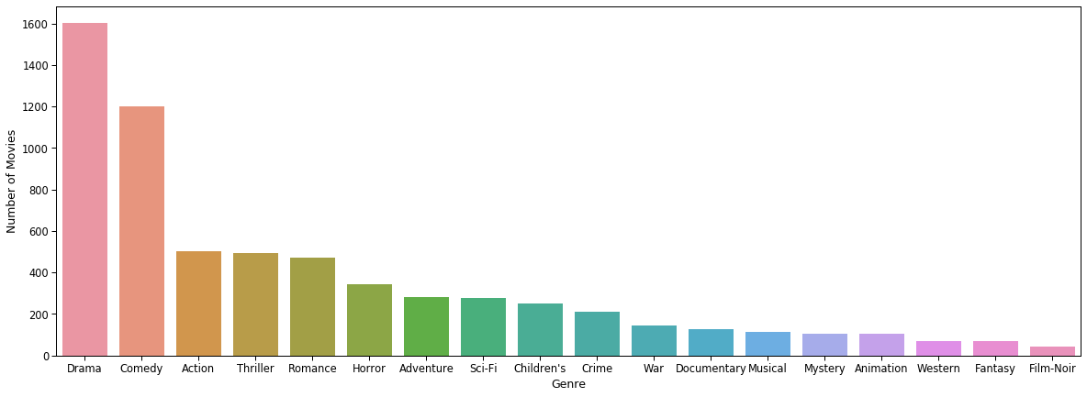

As we see, 50% of ratings are belongs to 2 genres ‘Drama’ and ‘Comedy’.

# Distribution of users in each age group and in each occupation

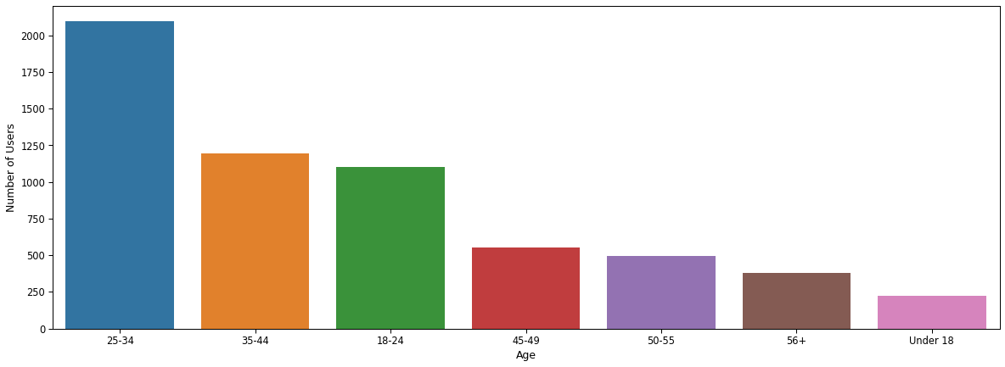

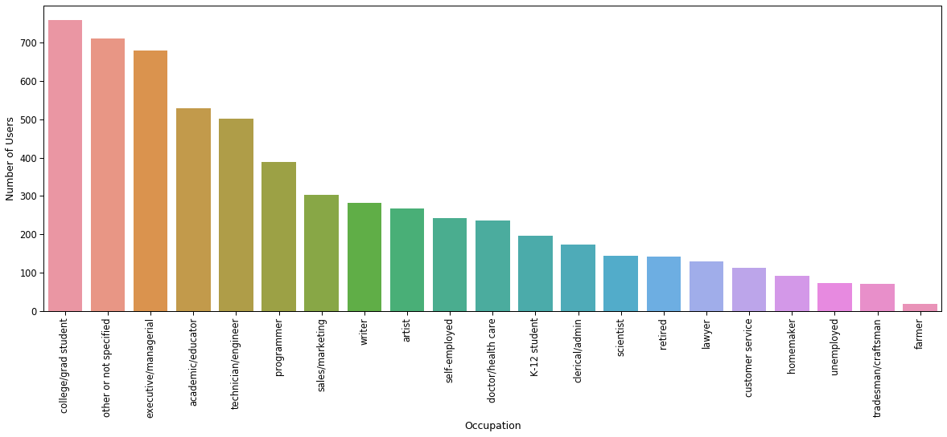

Most of users are between 18 to 34 years old and their occupation are one of these categories: Student, Executive, engineer or programmer

# Distribution of ratings

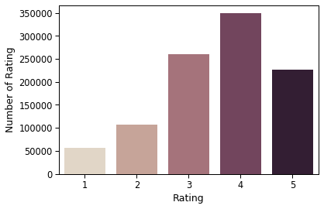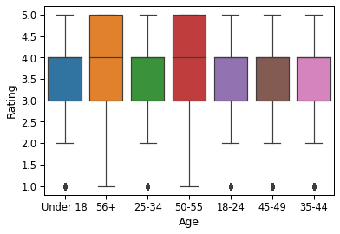

Portion of rating '4' is more than the other ratings and second box plot shows most of age groups has rating between '3' and '4'.

# Distribution of rating of most 5 popular genres in each age group

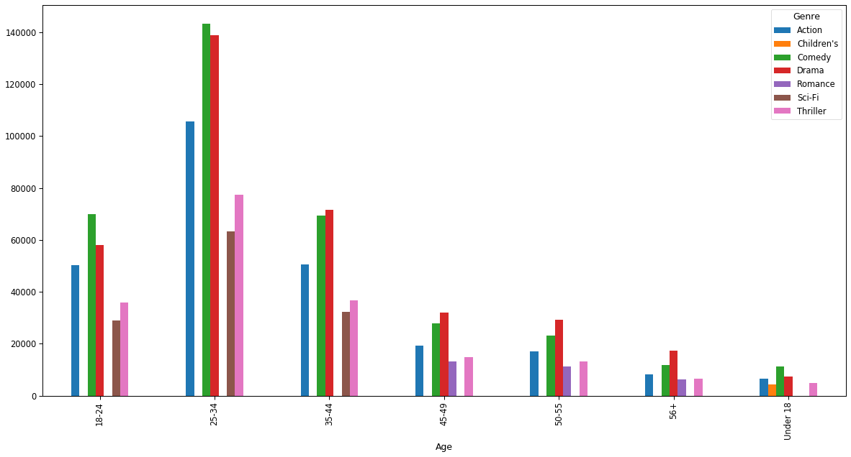

As we see, Comedy and Drama are most popular genre in each age group.

# Comparison of rating of each genre in each gender

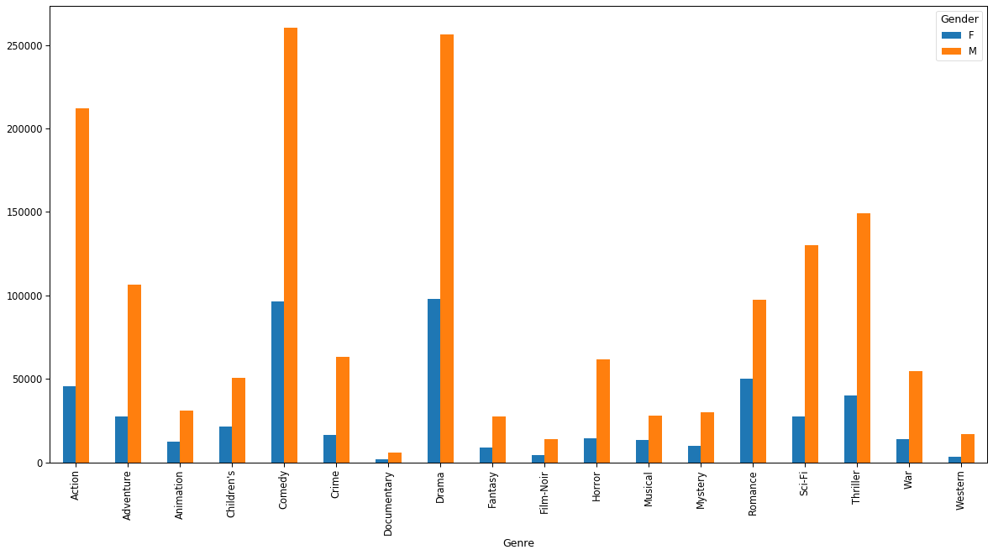

# - Distributation of rating for top five movies in dataset

# C:\Users\Amin\AppData\Local\Microsoft\Windows\INetCache\Content.MSO\B932964.tmp

# Correlation between number of ratings and average of ratings

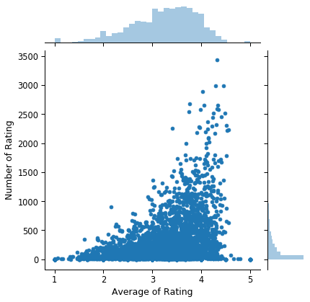

## EDA – Inferential Statistics

**In the following EDA, we try to perform analysis to find correlation between Number of Ratings and Average of Ratings for each movie.**

# **Initial observations for Correlation between Number of Ratings and Average of Ratings**

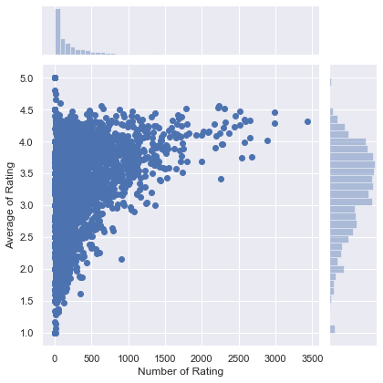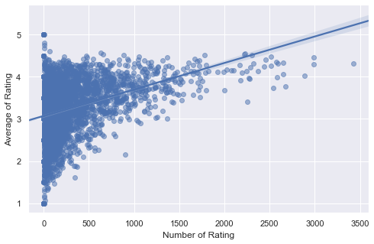

**Pearson correlation coefficient is 0.35, not equal zero and positive, which means when number of ratings increases, Average of Ratings increase, but the correlation is pretty weak.**

# **Setup hypothesis test**

**Ho : The Average of Ratings and Number of Ratings are independent**

**Ha : The Average of Ratings and Number of Ratings are correlated**

**Statistical significance for 𝛼 = 0.01**

**Test Statistic: Pearson correlation coefficient**

To do so, permute the Number of Ratings but leave the Average of Ratings values fixed. This simulates the hypothesis that they are totally independent of each other. For each permutation, compute the Pearson correlation coefficient and assess how many of our permutation replicates have a Pearson correlation coefficient greater than the observed one.

**As p-value less than**α**, we can reject the null hypothesis and accept alternative hypothesis which means that there is a correlation between number of ratings and average of ratings.**

**Generally, there is weak correlation between Number of Ratings and Average of Ratings for each movie in all genres with a very small p-value and less than α = .01, and small positive correlation between number of ratings and average of ratings with pearson_r 0.36.**

**After analyze correlation between Number of Ratings and Average of Ratings for 3 populare genres: Comedy, Drama and Action, turns out correlation between these two variables for genre Action is stronger than the other two genres.**